MURAYAMA, Tomoyoshi (January 18, 1901 – March 22, 1977)

Murayama Tomoyoshi was a leading artist of the avant-garde in interwar Japan. He is best known as a founding member and spokesman of the art collective Mavo (1923-1925).

As a youth, Murayama briefly attended Tokyo Imperial University, where he studied philosophy. He moved to Berlin in 1922 with the intention of studying early Christianity at Humboldt University. However, Murayama soon abandoned his plan of study, and his exposure to Expressionism, Dada, Futurism, and Constructivism in Europe attracted him to performance, theater, the visual arts, and the plastic arts. Before returning to Japan in 1923, Murayama crossed paths with important modernists such as Herwarth Walden, Aleksandr Archipenko, and Filippo Tommaso Marinetti. Murayama contributed work to ‘The Great Futurist Exhibition’ at the Neumann Gallery, as well as the First International Congress of Progressive Artists, which were both held in Düsseldorf. Upon returning to Japan, Murayama held his first solo exhibition in Tokyo in 1923 and began developing a theory of ‘conscious constructivism’ that called for the incorporation of everyday life into aesthetic practice.

Later in 1923, together with the artist, dramatist, and designer Yanase Masamu (1900-1945) and others, Murayama created the group Mavo. Mavo challenged prevailing notions of ‘pure’ art and medium specificity. Mavoists used confrontational artworks and anarchic performances as a means of challenging conventional tastes, exposing social hypocrisy, and incorporating everyday life into art. In this period, Murayama’s mixed media assemblages included references to popular culture, household goods, and industrial materials. He also produced work in many distinct media, including children’s illustration, commercial design, theatre, dance, and film. He sometimes collaborated with his wife, the children’s writer Murayama Kazuko (1903-1946). In 1923 the Great Kanto Earthquake destroyed Tokyo and created social unrest, influencing Mavo’s emphasis on repurposed detritus and construction, as well as politicizing many of its members. Murayama’s assemblages, such as *Construction That is Difficult to Name* (1924) incorporated disparate ‘found’ elements from modern industry, fashion, and advertising, and attempted to dismantle the barriers between ‘art’ and ‘life.’ Encouraged by the earthquake, Murayama and his cohort viewed the urban landscape itself as a field in which to work, and contributed several proposals for decorative facades, billboards, towers, and monuments for Tokyo’s reconstruction.

Over the 1920s, Murayama’s work became increasingly political, and its emphasis shifted from the visual arts to theatre. Murayama applied avant-garde aesthetic principles to theatrical creations in his work for Tsukiji Little Theatre, the Kokoro-za Theatre, and the New Cooperative Theatre. His most famous theatrical work is the Constructivist-style set he designed for the Tsukiji Little Theatre production of *From Morning Till Midnight* in 1924. Murayama became an active member of proletarian art associations and wrote political art criticism. His 1927 play *Sukāto wo haita Nero* (*Nero in a Skirt*) was censored by the authorities for being a criticism of the Imperial House. In 1929, the play *Bōryokudan-ki* (*A Record of Gangsters*) also drew the ire of the authorities because it glorified the resistance of Chinese communist labour leaders who were suppressed violently by the Japanese military in 1923. Murayama was arrested and held in police custody several times between 1930 and 1933, when he was forced to recant his political beliefs. In 1940, the New Cooperative Theatre and New Tsukiji Little Theatre were disbanded, and Murayama imprisoned.

After his sentence, Murayama spent the end of the war in Korea and Manchuria. Murayama returned to Japan in December, 1945, and began re-forming the New Cooperative Troupe in 1946 along with Kubo Sakae (1900-1958). Divisions within the communist movement eventually led the troupe to disband. Murayama still did not give up theatre, creating the Tokyo Art Theatre Troupe in 1959, and taking productions on tour to China and Korea in 1960 and 1966. His novel *Shinobi no mono* (1960-62) was adapted as a film series, play, and television program. He also completed a four-volume autobiography before his death.

Further reading:

Lewis, D. (2014) ‘Celebrity, Media, and Shame: *A Linked Heart Comedy, Life of an Artists (Or, An Operetta, Life and Heart of an Artist*) by Murayama Tomoyoshi (1923’, *Proceedings of the Association for Japanese Literary Studies* 15: 172-180.

Weisenfeld, G. (2002) *Mavo: Japanese Artists and the Avant-Garde, 1905-1931,* Berkeley: University of California Press.

\_\_\_\_. (1996) ‘Mavo’s Conscious Constructivism: Art, Individualism, and Daily Life in Interwar Japan’, *Art Journal* 55 (3): 64-73.

List of selected works:

*Portrait of a Jewish Girl* (1922). Oil, paper, wood, collage.

*Sadistic Space* (1921-1922). Oil painting.

*From Morning Till Midnight* set design for Tsukiji Little Theatre, 1924.

*Construction* (1925). Oil, paper, wood, cloth, metal, and leather.

*Research on Constructivism*. Tokyo: Chuo Bijutsusha, 1926.

*Introduction to Proletarian Film*. Tokyo: Zen’ei Shobo, 1929.

*Shinobi no mono*. Tokyo: Rironsha, 1962.

Paratextual material:

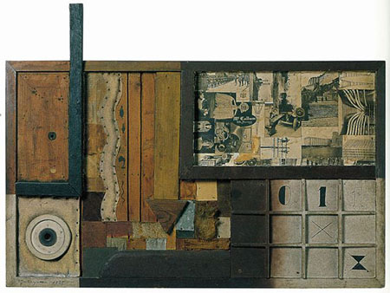

<https://www.frieze.com/issue/review/tomoyoshi-murayama/>

THE NATIONAL MUSEUM OF MODERN ART, [KYOTO, JAPAN](http://www.frieze.com/issue/back/category/kyoto_japan/)

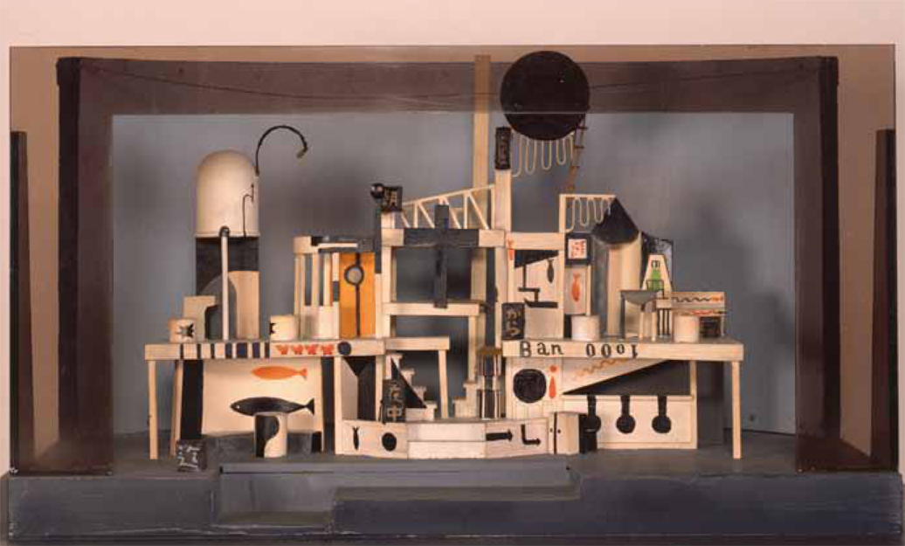

築地小劇場第49回公演『朝から夜中まで』(1926年再演) 舞台装置模型 [ギャラリーTOM](http://www.gallerytom.co.jp/" \t "_blank)

<http://ashbeesfragments.com/category/tomoyoshi-murayama/>